

**CUSTOMARY LAND SECRETARIAT MANAGEMENT APPLICATION**

**DUAYAW NKWANTA**

**USER MANUAL**

Reference: DUAYAW-001

Date: 7th September, 2018

Version: 0.1

Developed By: BitByte Technology Limited

Contact:

Email: [sorce100@gmail.com](mailto:sorce100@gmail.com)

Contact: 0547905169

**DECLARATION**

We the under signed developers of this projects, do declare that the project, DUAYAW CUSTOMARY LAND SECRETARIAT and its accompanying documentation were well executed by BITBYTE TECHNOLOGY LIMITED.

**Signature**

1. BitByte Technology Limited ……………………………………

Date:

**Signature**

1. Duayaw Customary Land Sec ……………………………………

Date:

# 

# SYSTEM SPECIFICATION AND DESIGN

This document describes the project implementation for developing the ushut. The project implements HTML5/CSS3, PHP, POSTGRES, and JAVASCRIPT. This project will be capable of running on any standard operating system.

# OFFICER PAGES OF DUAYAW CUSTOMARY LAND APPLICATION

## Main Page or landing page

***Introduction***: The main page of the application is the entry point for all the users of the application whether the user is an officer or an administrator.

***Data need:*** Each user will have a username and a password which will be created and given to him or her by the administrator of the application.

Example: a user called kojo Melvin will have a username **k.mevlin**

And password will be **Melvin@123** which can be changed after the initial login

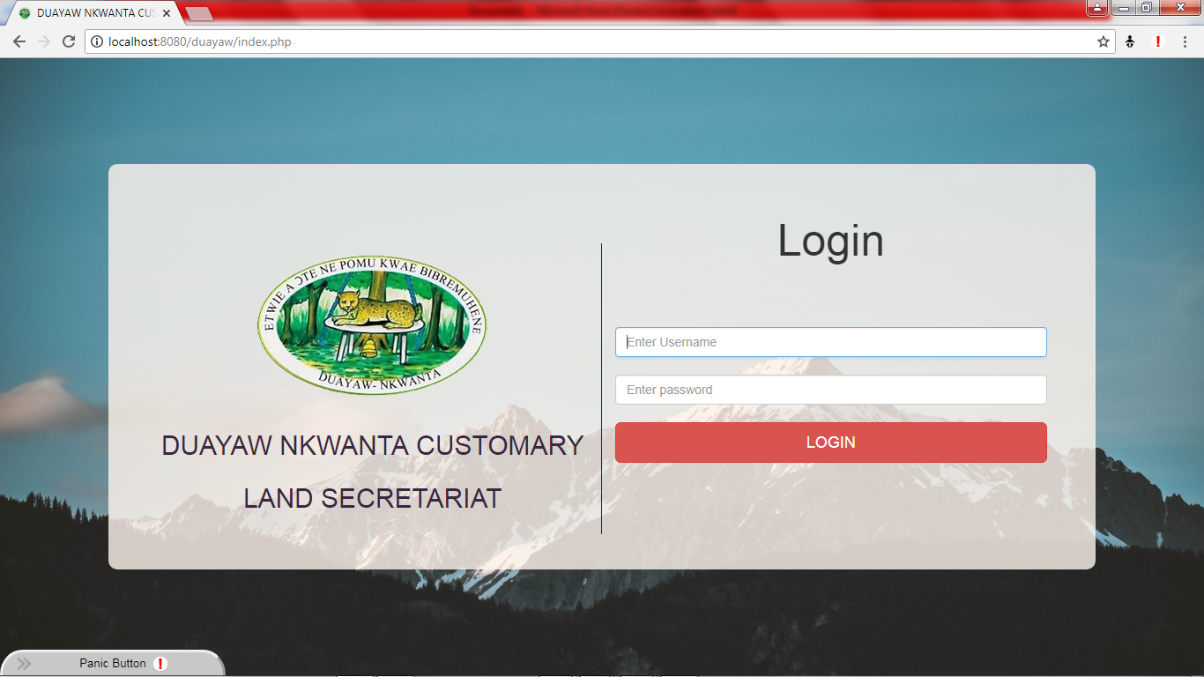

Melvin@123

**k.mevlin**

## Dashboard Page

***Introduction***: On successful login into the application with right username and password, then comes the dashboard page. Contains summary of all entries made for customary land applications, farm land application and general documents that have being saved using the application. It also has a button to enable printing or save to pdf a custom letter head.

***Details:*** On the left side of the page the user can access the menu tabs which is different depending on if the user is a general officer or an administrator of the application.

Then in the middle of the page are the summary buttons and the letter head print button.

On the top right of the page is the name of the user that on click, user can change his or her password that was set by administrator

***Data need:*** No data needed

Summary tabs and print button

Click to change password

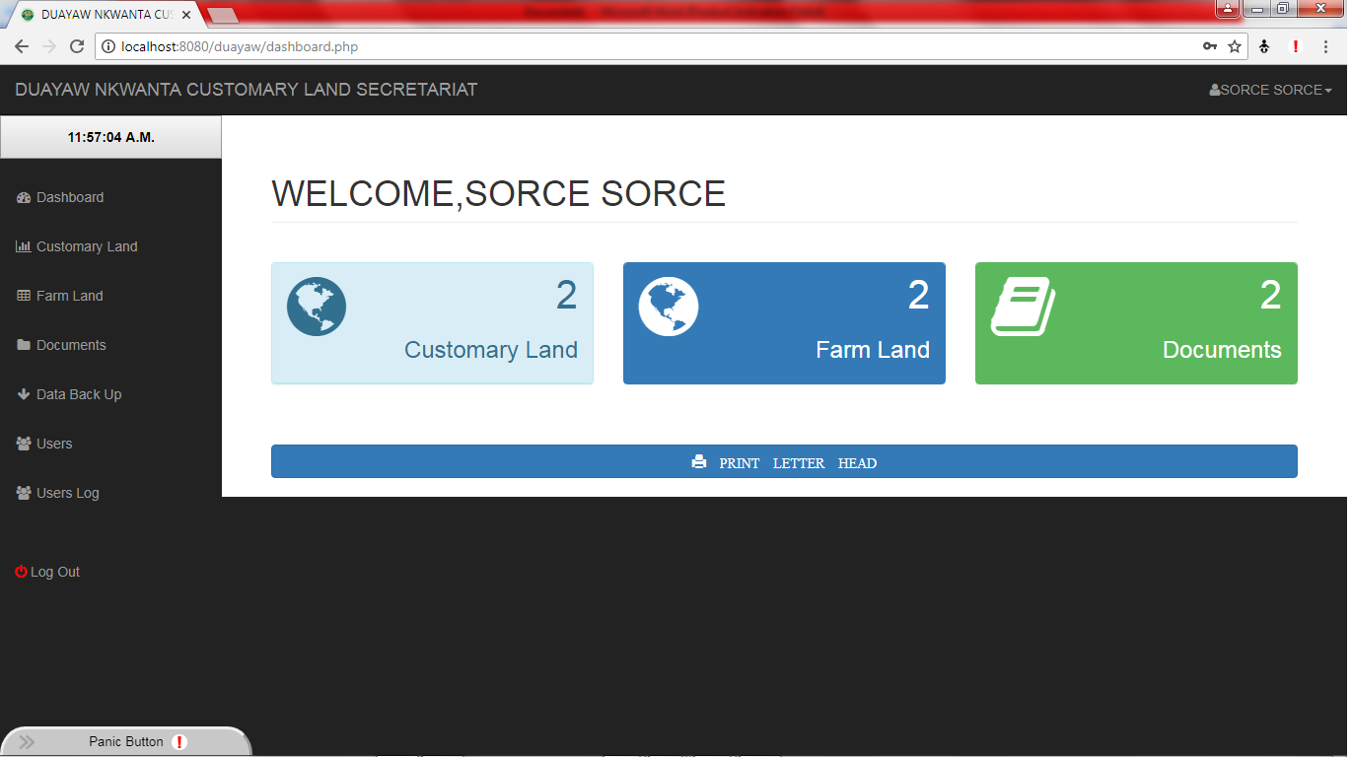

Menu tabs

# Customary Land Page

***Introduction***: This is the page used for saving new customary land details as well as viewing and updating of records already inserted. Uploading all relevant document associated with each application.

Officers can also search and view entries already made by other officers and update all out dated documents.

***Data need:*** Details and scanned softcopy versions documents of client that wants to register his or her customary land with the secretariat

Click to search for all ready existing details saved in the software

Summary details of entries made in the database

Click to add new details of an applicant

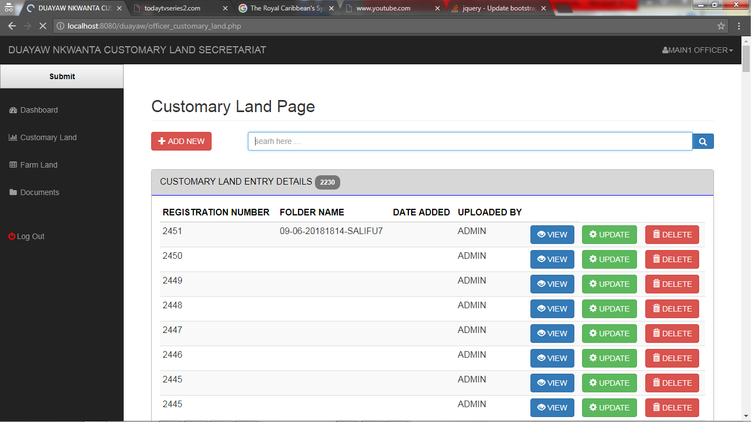

Click to Update applicant records of each entry made by an officer

Click to delete each entry made by an officer

Click to View each entry made by an officer

Total entry

## Add New Customary Land details

On Click of the add new button on the customary land page, a modal or form will be displayed for users officers to add new details of clients.

Fill in all available and necessary customary land details to be saved for an applicant

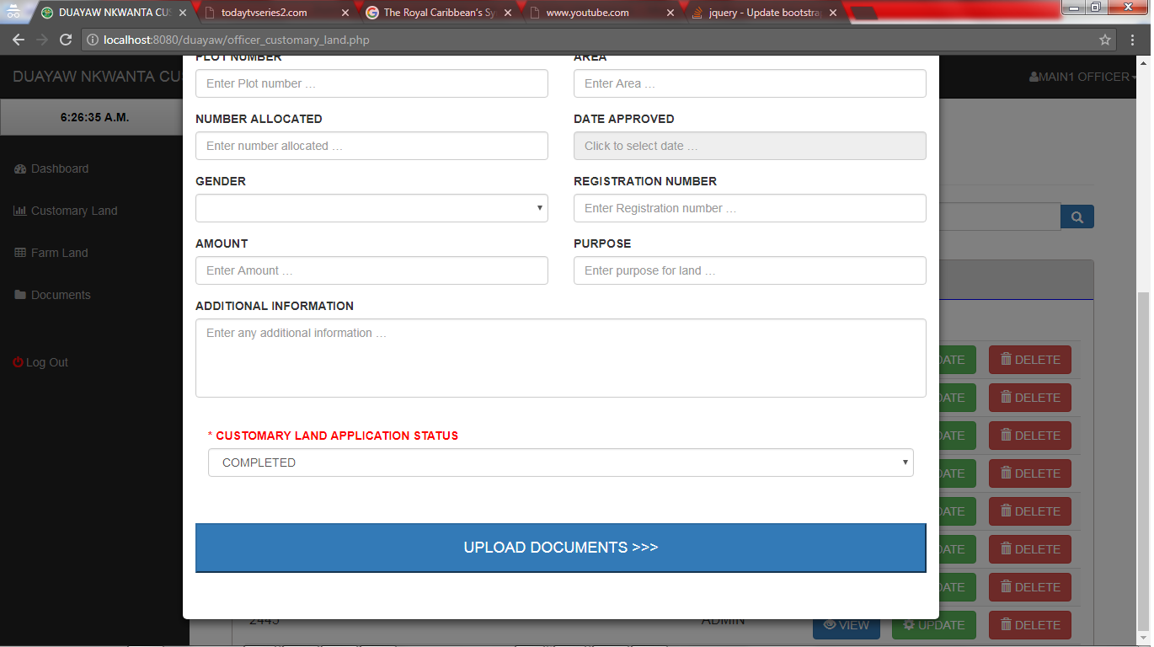

Click to go to page to select and add all necessary documents associated with this entry scanned and labeled well

**PLOT NUMBERS FOR MULTIPLES PLOTNUMBERS SHOULD BE ENTERED IN THIS FORMAT**

**EXAMPLE: 111,122,19,6 G4 NKWANTA SHOULD BE ENTERED AS 111 G4 NKWANTA, 122 G4 NKWANTA, 19 G4 NKWANTA, 6 G4 NKWANTA**

## Upload documents of Customary Land details

This is the page for uploading all necessary documents scanned and labeled well associated with each entry; you can either choose to save the details of the applicant without the attached documents to be later updated or you can add the files.

Click on the blue button “CLICK TO ADD MORE FILES” to add files associated up to 20 documents are allowed per applicant.

Button to click to add new files

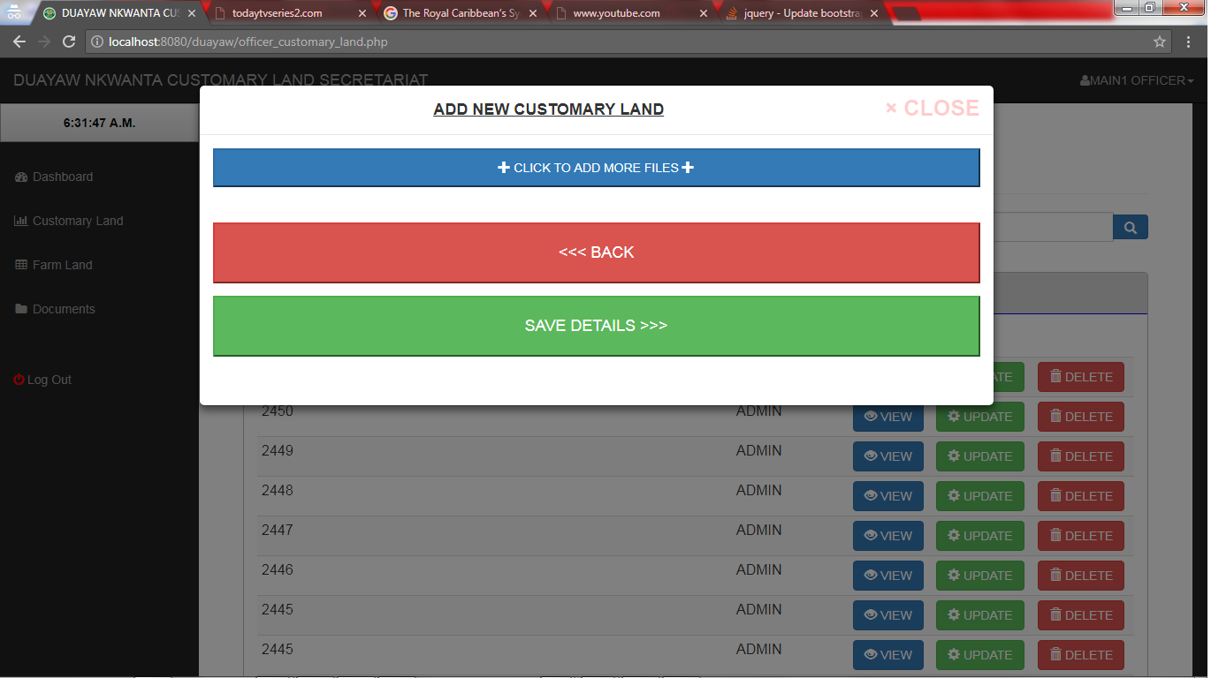

Button to click to go back to view details of applicant associated

Button to click to save details of applicant in the database

## Adding of documents

On Click of the “CLICK TO ADD MORE FILES”, a button form is inserted with “choose file” and “DELETE”. The choose file will open the system explorer where officer can choose the file waiting to be uploaded, as well if an entry is made as a mistake, officers can delete the chosen file before submission.

Click to add new file

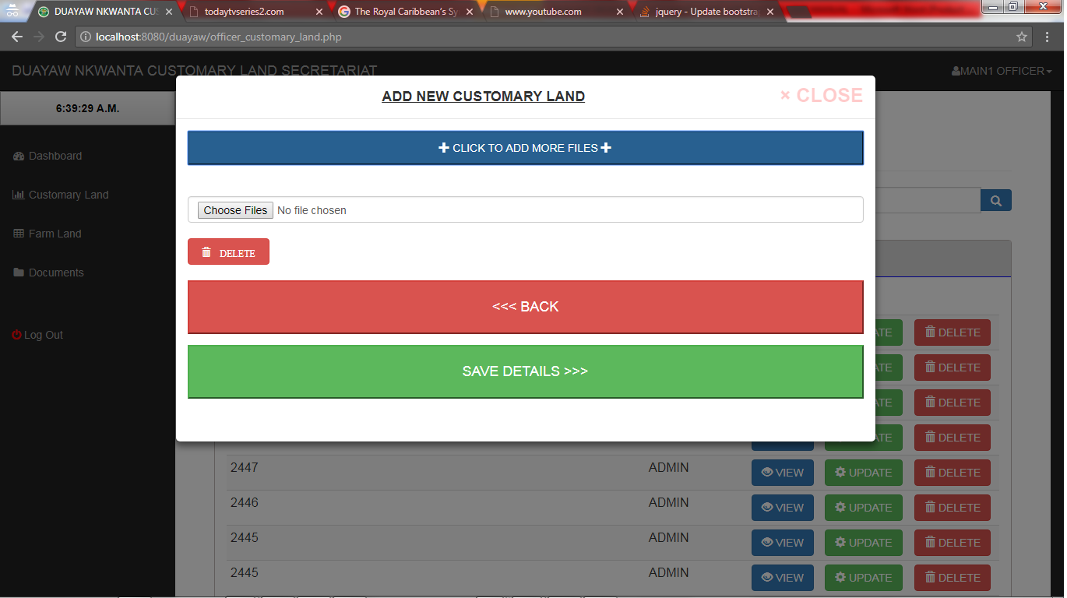

System explorer to choose file from

You click to highlight on the file you want to choose then you click on open to submit that file.

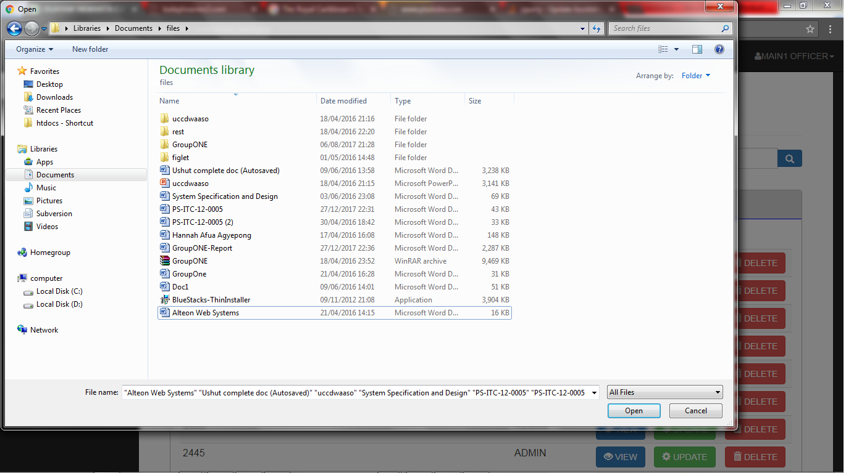

## Viewing details of entry made

To view the details of entry made for each applicant which can be done through the search form on the customary land page, the officer should click on the blue button with “VIEW” on it to view details.

Details on the view cannot be changed, but only to be looked at download to view all necessary attached documents

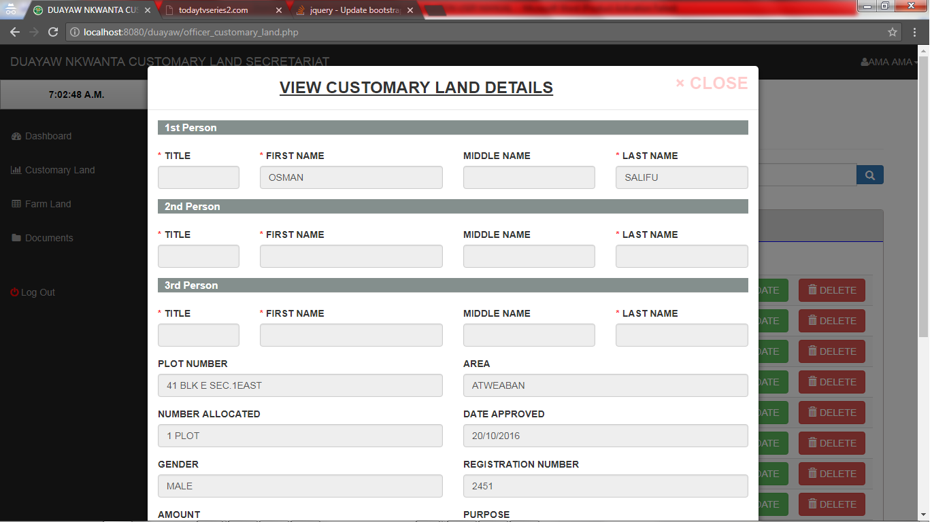

## Viewing documents of entry made

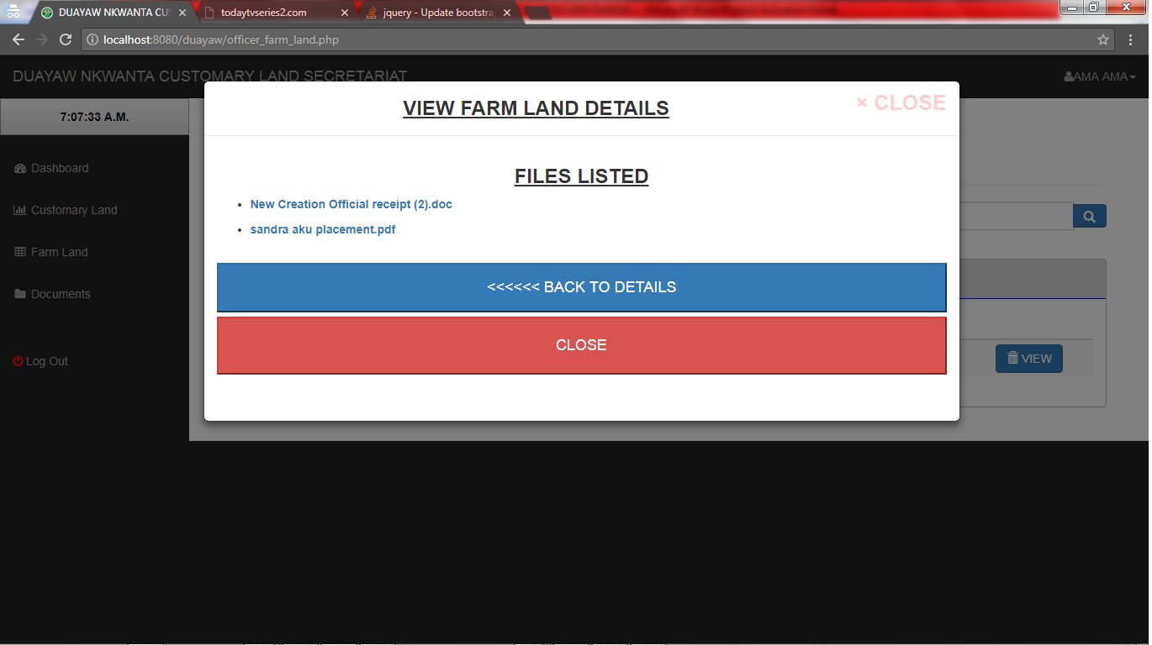

Click on any file to download and view records

## Updating records and documents associated with each user

Officers can change records and document of each applicant already saved in the database by clicking “UPDATE” on the customary land page

Click to delete a file associated with this entry

Click to add files and update

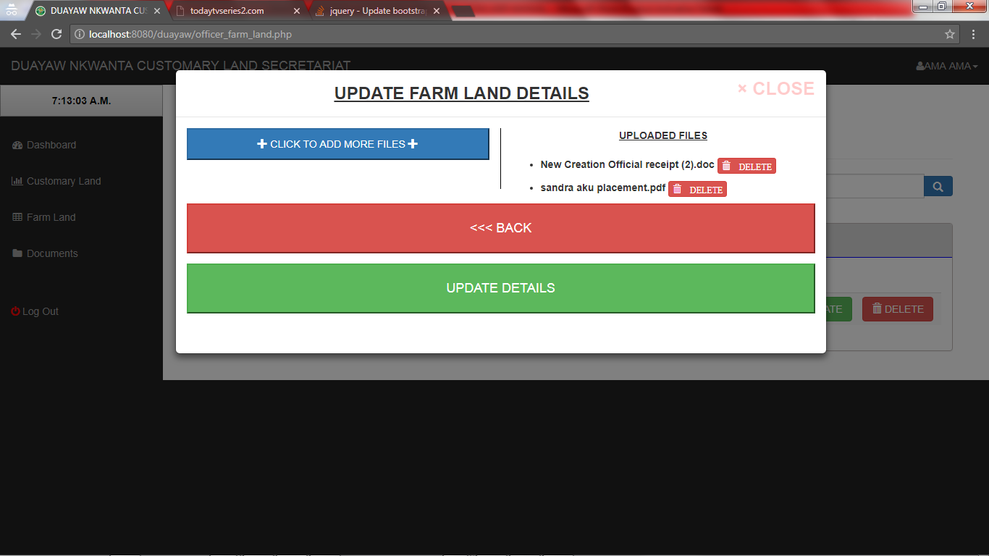

Save changes of the update

# FARM LAND Page

Please refer to customary land specifications as it is the same procedure.

# DOCUMENTS PAGE

Please refer to customary land specifications as it is the same procedure.

**END OF OFFICER DOCUMENTATION**